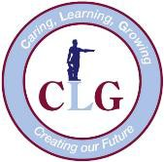
Coronavirus Update 3

3 February 2020

Dear parent/caregiver,

Public health officials have updated advice over the weekend regarding Novel Coronavirus.

We would like to underline the importance of following this advice and alert you to the new national information hotline: 1800 020 080.

The updated advice from SA Health is effective from Saturday 1 February 2020:

- Children or staff who travelled to mainland China must isolate themselves in their home for 14 days after leaving mainland China if they left mainland China on or after 1 February 2020.
- Children or staff who have been in close contact with a confirmed case must isolate themselves in their homes for 14 days after last contact.
- Children or staff who have returned from Hubei Province, China must isolate themselves in their home for 14 days after leaving Hubei Province.
- Staff and students in these circumstances must not attend schools, preschools or early childhood centres and should not engage with other students.

Symptoms may include fever, cough, shortness of breath, fatigue and sore throat. People with these symptoms who have travelled to China or have had close contact with a confirmed case should see a doctor or attend a hospital and call ahead so they can prepare.

We will keep you updated if new information becomes available.

Yours sincerely
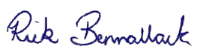
Rick Bennallack
Principal
(08) 8276 1523  0412 261 231
rick.bennallack149@schools.sa.edu.au

